Townscape Assessment Report
This Report tells (i) what datasets were used and how they were collected, (ii) how each townscape attribute (TA1–TA9) was measured, and (iii) how the outputs relate to the 9 GLVIA3 factors. We operationalised the nine GLVIA3 townscape attributes with open data and a reproducible ML+GIS workflow based on TownscapeBench. The complete report can be seen in the GitHub Repository. We summarised results as maps and statistics, using t-tests, Mann–Whitney U, Pearson r, and Cohen’s κ for validation where applicable as shown in Appendix E and F. It integrates open data to quantify nine townscape factors for Amsterdam’s Centrum and IJburg. Building form and street structure were derived from 3DBAG and OSM, with terrain from AHN and water, land use, and trees from public sources. Street‐level enclosure indicates a largely moderate urban canyon effect in the canal belt. Topography shows negligible control on height because the terrain is flat. Grain metrics separate the historic core from the planned district, with smaller plots and greater frontage in Centrum. Spacematrix indicators confirm a compact fabric with moderate coverage and relatively high intensity. Land-use composition is dominated by built areas and water, with green spaces more dispersed.
Water strongly frames the street network spatially, yet proximity to canals does not alone raise enclosure. Vegetation along streets could not be fully evidenced due to a transient tree feed, but the method supports trees-per-kilometre diagnostics. Open-space mapping shows that larger, more open cells tend to be less central in the network. Connectivity analysis highlights high intersection density and clear strategic routes within the historic grid. Taken together, the metrics provide a transparent, reproducible account of context, form, function, and accessibility. They align with GLVIA3 by linking measurable spatial structure to experienced character and by distinguishing historic fine-grain morphology from more recent, coarser development.
- Study area, data collection & processing
Two contrasting Amsterdam districts were used to demonstrate metrics: Centrum (historic fine grain) and IJburg – Haveneiland (planned coarse grain). AOI boundaries were geocoded and projected to EPSG:28992 (RD New).
1.1 Data source: Open datasets
- Buildings / heights: 3DBAG LoD1.3 via WFS (fallback: OSM building=*). Used building footprints and height attributes; heights were also estimated as floors×3.0 m where only floor counts existed.
- Street network: OSMnx pedestrian graph from OpenStreetMap; edges re-projected to RD New with edge lengths.
- Terrain: AHN DTM (WCS). Clipped to AOI and sampled under building footprints for slope (Horn).
- Land-use: CBS ELU WFS (when the service responded); fallback: OSM land-use tags (landuse, natural, leisure) harmonised to {built, water, green, other}.
- Water: OSM natural=water, waterway=*, dissolved to water polygons.
- Trees: Amsterdam Trees API GeoJSON (nearest-edge match within 20 m). If the API timed out, TA7 values are NA and the map just draws the network.
- Reference outputs: All layers were written to a single GeoPackage for audit; summary numbers are Appendix 4.
1) TA1 — Context / setting (relationship to wider landscape)
Street Enclosure Index (EI) per street segment, EI = median façade “height signal” seen by a 20 m offset sampler on both sides (proxy for height-to-width).
Data source:
- Buffers were cast along both sides of each OSMnx edge.
- For each buffer, intersected building footprints and took a robust height statistic (median).
- Near-water vs far-from-water comparison used the water polygons (≤50 m threshold) and a two-sample t-test.
Analysis
- This maps the setting character felt along streets and shows whether landscape edges (canals) modify the perceived enclosure. (In Centrum, effect was negligible.)
- The street network coloured by an enclosure index (EI ≈ building height / 20 m buffer). Warm segments are “canyon-like” streets; cooler ones are more open.
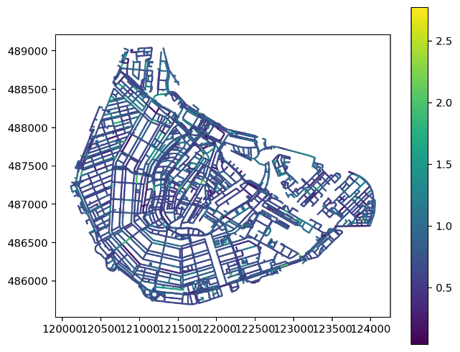
- Streets are mostly low–moderately enclosed (EI ~0.4–1.2), with a few canal-ring corridors more enclosed (dark strokes).
- Proximity to water does not materially change enclosure in this AOI:
t = −0.159, p = 0.874, effect d = −0.007 (negligible).
(Amsterdam’s canals tend to have consistent building lines on both banks.)
- It captures the urban setting/character along streets and how edges (canals) shape the feel of the public realm.
2) TA2 — Topography and its relationship to urban form
Correlation between terrain slope (°) and building height (m).
Data Source
- Sampled AHN DTM inside each footprint; slope by Horn kernel.
- Joined to building height (3DBAG or floors×3 m).
- Pearson correlation r(slope, height) and a diagnostic scatter.
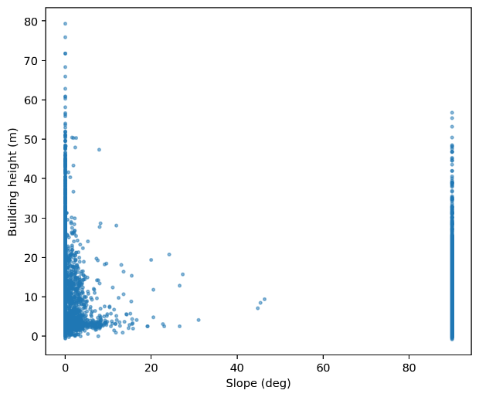
Analysis
- Tests whether relief controls building form. In Amsterdam’s flat terrain, it doesn’t (weak negative r).
- scatter of building height vs. terrain slope from AHN DTM sampling.
- Pearson r (slope, height) = −0.229 (weak negative).
- Amsterdam is very flat, so height varies largely independently of slope. The vertical band at ~90° are DTM artefacts at raster edges — they don’t drive the correlation (still weak if dropped).
- It shows terrain has minimal influence on built form here (unlike hillside towns).
3) TA3 — Grain of built form & historic patterns (burgage plots)
Parcel/plot size proxy and street-frontage length per building (two complementary grain descriptors).
Data Source
- In current run, the tessellation (momepy) produced pseudo-plots; we compared plot areas (Centrum vs IJburg) with a Mann–Whitney U test.
- In the fast version, we skip Voronoi and compute frontage length by intersecting each building’s boundary with a 3 m street buffer; plot proxy area = footprint area.
Analysis
- Fine historic grain (small plots, long street frontage) vs coarse modern grain (large parcels) evidences historic patterning akin to burgage plots.
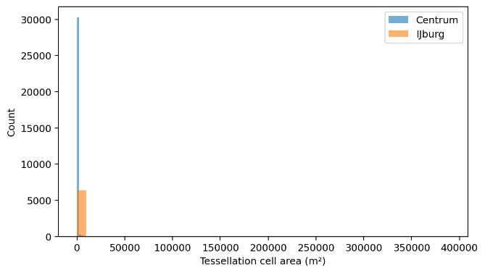
- Histogram comparing parcel/plot proxies (your run used tessellation cell areas) for Centrum vs IJburg.
- Headline test: Mann–Whitney U = 8.23×10⁷, p ≈ 1.7×10⁻⁹⁷ → distributions differ strongly.
- Centrum has many small plots (historic, fine grain); IJburg shows much larger units (planned, coarse grain). That’s the classic burgage-like fine grain vs new-town super-plots contrast.
- GLVIA3 relevance directly evidences historic grain differences.
4) TA4 — Layout, scale, density & types (period/material proxy)
Spacematrix indicators from buildings:
- GSI (Ground Space Index) = total footprint area / AOI area
- FSI (Floor Space Index) = total floor area / AOI area
- L (Open Space Ratio) = (AOI area − footprint area) / AOI area
- floors↔height r as an internal consistency check
Data Source
- Floor area = footprint × floors (from tags) or height/3 m where floors were missing.
- Aggregated per AOI.
Analysis
- It Summarises layout intensity, building scale and density. If you later add façade material/period tags (or ML façade classification), the “types” part completes.
- Spacematrix text card.
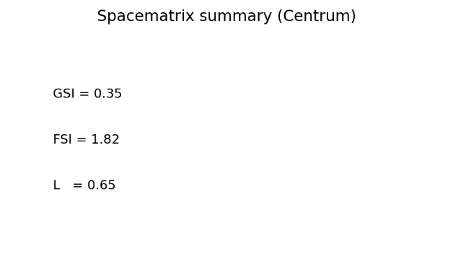
Metrics (Centrum):
- GSI = 0.35 (ground coverage)
- FSI = 1.82 (total floor area / site area)
- L = 0.65 (open space ratio)
- Floors vs height correlation: r = 0.280 (sensible, not perfect due to missing tags)
A compact historic fabric (moderate coverage, relatively high total floors). Good single-number descriptors of scale & intensity. It quantifies layout/scale/density; period/materials could be layered later via façade/OSM tags.
5) TA5 — Patterns of land use (past/present)
Land-use composition (area) and agreement between proxy (OSM) and official ELU (when available).
Data Source
- Harmonised OSM tags to {built, water, green, other}; dissolved and area-summed.
- When CBS ELU was available, we overlaid and computed accuracy and Cohen’s κ
Analysis
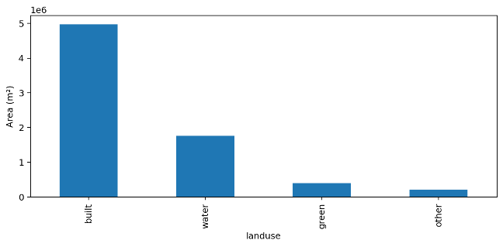
- It captures the functional structure underpinning townscape character and validates it against an authoritative source.
- Ttop land-use area bar chart (OSM-derived fallback).
- Validation vs official ELU (where available):
Accuracy = 0.509; Cohen’s κ = 0.235 (fair).
(We fell back to OSM’s coarse classes because CBS ELU WFS timed out; expect κ to improve with full ELU.)
- The AOI is predominantly built, then water, then green — exactly what you expect around the canal belt.
- It describes functional composition of the townscape and how it changed toward water/green pockets.
6) TA6 — Contribution of water
- Share of street length within 50 m of water.
- Relationship between distance to water and enclosure (corr).
Data Source
- Buffered water polygons; intersected with edges to compute adjacency share.
- Computed nearest distance to water for each edge; correlated with EI.
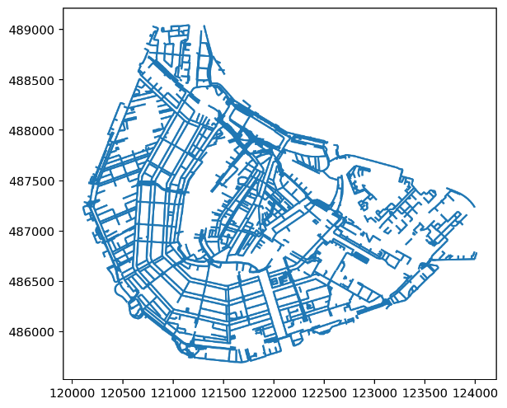
Analysis
It quantifies how waterscape frames and permeates the urban experience.
Map of waterfront street segments (within 50 m of water).
Metrics:
- 66.8 % of street length lies within 50 m of water.
- Corr(dist-to-water, enclosure) = −0.010 (none).
Water is ubiquitous in the Centrum network (canals everywhere), but enclosure is mostly set by building height/continuity, not just canal adjacency.It quantifies how water structure interweaves with streetscape character.
7) TA7- Vegetation: type/location & relationship to buildings/streets
Trees per kilometre along streets and (optionally) their relationship to mapped green land-use.
Data Source
- Pulled Amsterdam trees as points; nearest-edge match within 20 m; aggregated counts → trees/km by dividing by edge length.
- (If ELU green polygons available) computed distance to green and correlated with trees/km.
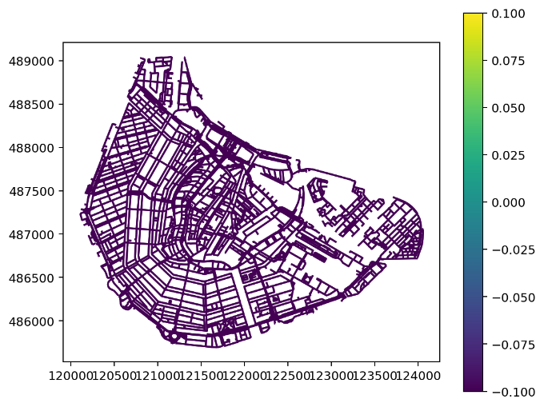
- In your run the tree API timed out, so the metric registers NA; re-run once the feed is reachable.
Analysis
- Describes the green structure lining streets, its distribution, and how it complements built enclosure.
- Graphic: streets coloured by trees per km (nearest-edge count within 20 m).
- Data note: the Amsterdam trees API timed out during your run, so the global mean stored is 0.00 trees/km (i.e., NA). Re-run when the API responds and you’ll get sensible tree densities; the pipeline will also correlate trees/km with distance to mapped green.
- It measures green structure and how it lines the street edge; relates planting to enclosure and land-use.
8) TA8 — Types of open space & public realm
Open Space Index per 100×100 m grid cell:
OSI = 1 − (built area in cell / cell area).
We related OSI to network closeness to gauge centrality of open spaces.
Data Source
- Generated a regular grid clipped to AOI; intersected footprints to get built fraction.
- Found each cell’s nearest network node; joined closeness centrality.
- Correlated OSI with closeness.
Analysis
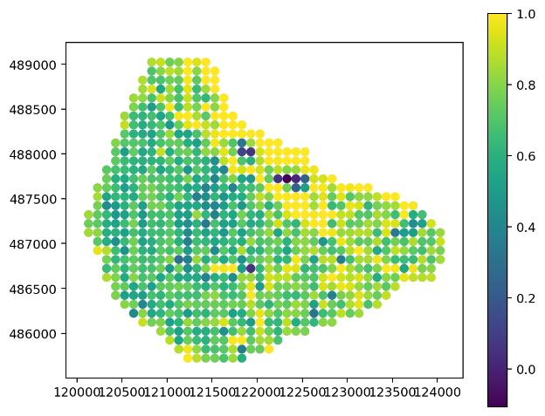
- Links public-realm openness to spatial accessibility (e.g., large squares off the main grid tend to be less central).
- 100 m grid Open Space Index (1 – built fraction in 100×100 m cells).
- Corr(Open-space index, local network closeness) = −0.255 (moderate).
- Bigger open spaces tend to be less centrally embedded in the network (squares/parks off the main grid), which affects activity intensity and perceived liveliness.
- Links public-realm openness to accessibility, a key dimension of townscape quality.
9) TA9 — Access & connectivity (streets & footways)
- Intersection density (nodes with degree ≥3 per km²).
- Average edge circuity (edge length / Euclidean node distance).
- Node betweenness (sampled on the largest connected component for speed).
Data Source
- OSMnx graph → undirected; degrees → intersection count / AOI area.
- Circuity computed edge-wise and averaged.
- Betweenness with a node sample (k) for tractability; mapped for interpretation.
Analysis
- Captures permeability and legibility—core to pedestrian experience and urban form.
- Full network plan; node betweenness dots (centrality).
Headline metrics (Centrum vs IJburg):
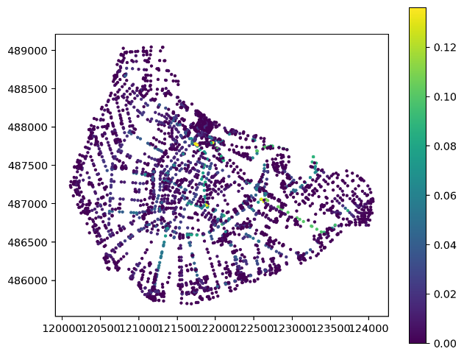
- Intersection density: 384 vs 149 / km² → Centrum is far finer grained.
- Circuity (edge length / straight line): 1.037 vs 1.056 → both fairly direct; IJburg slightly more winding.
- Betweenness map: highlights canal-ring spines and connecting bridges as the most strategic paths.
It captures permeability/connectivity that underpins legibility and pedestrian experience.

